Circuit Schematic

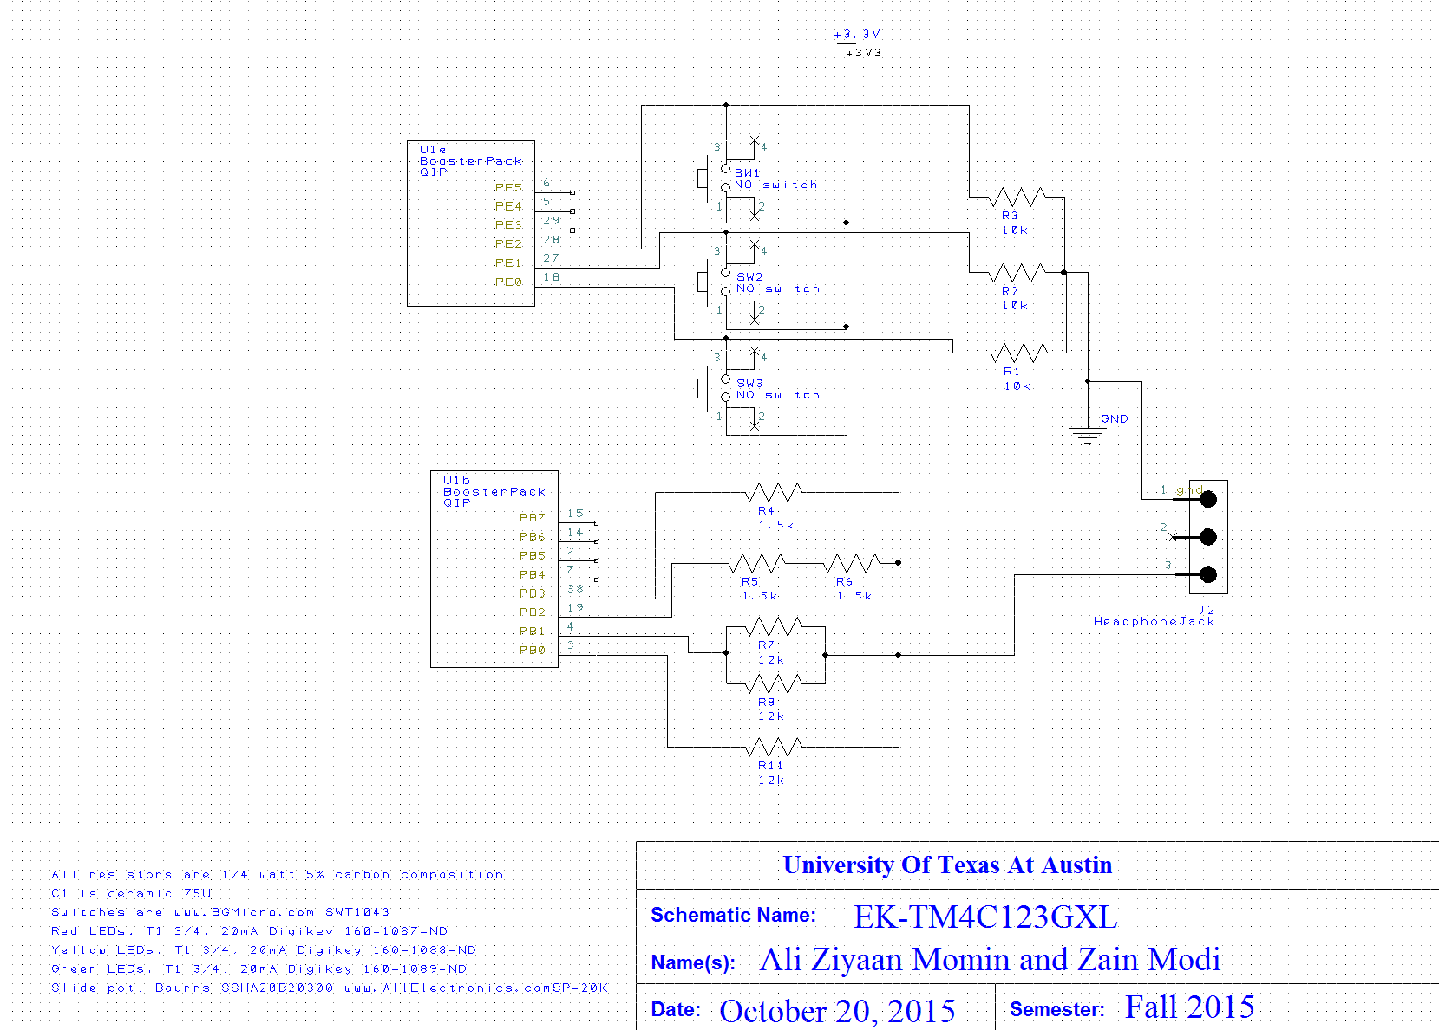

Oscilloscope Measurements

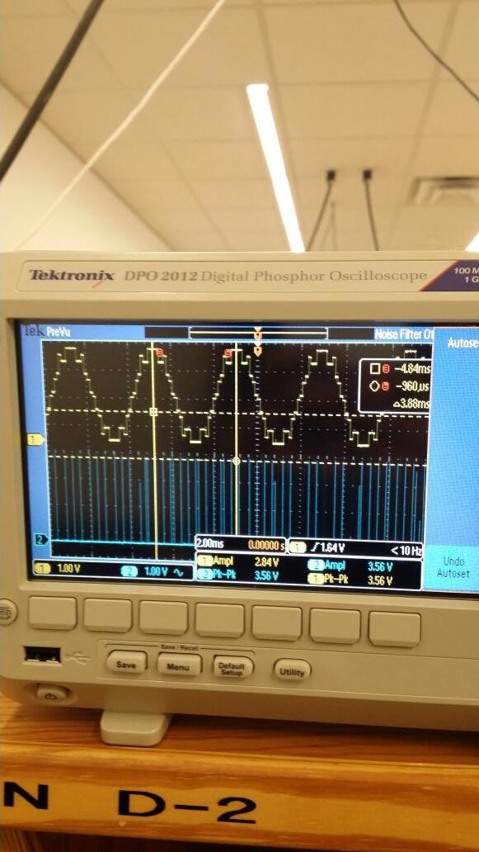

Sine Table Array for Piano wave:

|  |
| --- |
| SinTab[0] 8 |
| SinTab[1] 9 |
| SinTab[2] 11 |
| SinTab[3] 13 |
| SinTab[4] 14 |
| SinTab[5] 14 |
| SinTab[6] 15 |
| SinTab[7] 15 |
| SinTab[8] 15 |
| SinTab[9] 15 |
| SinTab[10] 14 |
| SinTab[11] 14 |
| SinTab[12] 13 |
| SinTab[13] 11 |
| SinTab[14] 9 |
| SinTab[15] 8 |
| SinTab[16] 7 |
| SinTab[17] 6 |
| SinTab[18] 4 |
| SinTab[19] 2 |
| SinTab[20] 1 |
| SinTab[21] 1 |
| SinTab[22] 0 |
| SinTab[23] 0 |
| SinTab[24] 0 |
| SinTab[25] 0 |
| SinTab[26] 1 |
| SinTab[27] 1 |
| SinTab[28] 2 |
| SinTab[29] 4 |
| SinTab[30] 6 |
| SinTab[31] 7 |

|  |  |  |
| --- | --- | --- |
| Bit3 bit2 bit1 bit0 | Theoretical DAC voltage | Measured DAC voltage |
| 0 | 0V | 0V |
| 1 | 0.22V | 0.219V |
| 2 | 0.44V | 0.438V |
| 3 | 0.66V | 0.657V |
| 4 | 0.88V | 0.878V |
| 5 | 1.1V | 1.089V |
| 6 | 1.32V | 1.320V |
| 7 | 1.54V | 1.538V |
| 8 | 1.76V | 1.757V |
| 9 | 1.98V | 1.979V |
| 10 | 2.2V | 2.187V |
| 11 | 2.42V | 2.417V |
| 12 | 2.64V | 2.638V |
| 13 | 2.86V | 2.859V |
| 14 | 3.08V | 3.067V |
| 15 | 3.3V | 3.258V |

Range(volts) = Precision * Resolution(volts)

Range = 3.3-0 = 3.3V

Resolution = 16V

Precision = 0.206

Accuracy = 0.4545%

Brief, one sentence answers to the following questions

* 1. When does the interrupt trigger occur?

It occurs when the value of the current register in the SysTick hits 0.

* 1. In which file is the interrupt vector?

Startup.s

* 1. List the steps that occur after the trigger occurs and before the processor executes the handler.

The PC and the PSR get saved onto the stack.

* 1. It looks like **BX LR** instruction simply moves LR into PC, how does this return from interrupt?

Before the Handler is executed, the PC saved to LR is the incremented PC therefore when PC is restored back, it points to the next instruction in the program (this is for returning from a subroutine). An arbitrary value will be put into the link register to indicate that it is indeed returning from an interrupt rather than a subroutine.